SS14 Fixed-Income
Thursday, May 23, 2019
3:46 AM

READING 45. Asset-backed Securities

- Explain benefits of securitization for economies and financial markets
- Describe securitization, including the parties involved in the process and the roles they play
- Describe typical structures of securitizations, including credit tranching and time tranching
- ABS Issue entity: structured finance sector, not corporate
- Securitization: benefits to investor: managed credit risk exposure, complex structure; benefits to investors: can expose to a wider range of assets. Parties: seller, SPE(issue ABS), servicer of loans(responsible for payment collection and recovery default); all other underwriters, rating agencies, financial guarantors are third parties.
- Internal subordination(aka credit tranching): redistribute credit risk associate w collateral, so investors can choose credit risk they bear. Time tranching: diff expected maturities, cuz repayment risk(uncertainty of cash flows not scheduled, extension & contraction risk).
- Absolute priority rule holds in bankruptcy liquidation, violates bankruptcy reorganization.
- Describe types and characteristics of residential mortgage loans that are typically securitized
- Loan-to-value ratio(LTV): mortgage amount to property's value, lower LTV higher equity. Mortgage rate(aka contract, note): fixed, adjustable/variable, initial period fix, convertible. Recourse loan: lender has claim against borrower for any shortfall; Non-recourse loan: no claim but only the sale of property to recover outstanding mortgage.
- Bullet(interest-only lifetime) mortgage: no scheduled principal repmt, payback @maturity.
- Agency RMBS: by federal agency & GSE(government-sponsored enterprise); Non-agency RMBS: private entities. If not meeting agency RMBS, it's a non-conforming mortgage.
- Describe types and characteristics of residential mortgage-backed securities, including mortgage pass-through securities and collateralized mortgage obligations, and explain the cash flows and risks for each type
- Pass-through created when holders form a pool of mortgages and sell shares/certificates in pool; pass-through rate=coupon - serve. Weighted avg coupon rate(WAC), weighted avg maturity(WAM), weighted avg life, prepayment measure of CPR(annualized SSM single).
- Define prepayment risk and describe the prepayment risk of mortgage-backed securities
- Collagenized mortgage obligation (CMO): securitization of a pool of mortgage pass-thru loans. Sequential pay CMO: each tranche retired sequentially; Panned Amortization Class (PAC CMO): predictivity of cash flows following repayment rate; PCA tranche has less variability in avg life, support tranche has more variability in avg life and can offer higher return bearing prepayment risks(contraction & extension), all compared to mortgage pass-thru securities. CMO and commercial mortgage-backed securities are back by mortgages only.
- Describe characteristics and risks of commercial mortgage-backed securities(CMBS)
- 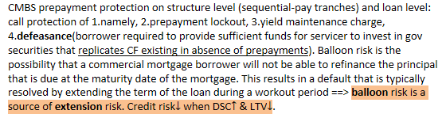
- Describe types and characteristics of non-mortgage asset-backed securities, including the cash flows and risks of each type
- 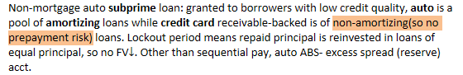
- Describe collateralized debt obligations, including their cash flows and risks
- Collateralized debt obligation (CDO) are structured securities backed by a pool of debt obligations that is managed by a collateral manager. ABS collateralize underlying pool of assets; MBS collateralize a pool of mortgage-backed securities. CDO worries additionally manager fails to earn enough returns to pay senior & mezzanine tranches. CDO includes:
- Collateralized bond obligations (CBOs) backed by corporate and emerging market debt.
- Collateralized loan obligations (CLOs) backed by leveraged bank loans.
- Structured finance CDOs backed by residential or commercial MBS, ABS, or other CLOs.
- Synthetic CDOs backed by credit default swaps on structured securities.

READING 46. Understanding Fixed Income Risk and Return

- Calculate and interpret the sources of return from investing in a fixed-rate bond
- 1.Coupon and principle payments, 2.Reinvestment of coupon payments, 3.Capital gains or loss if bond is sold before maturity. A point on trajectory represents the carrying value of the bond at that time.
- Define, calculate, and interpret Macaulay, modified, and effective durations
- 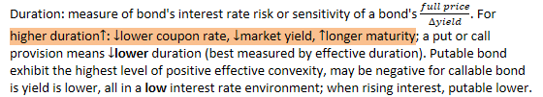
- Duration gap = Macaulay duration - investment horizon.
Investment horizon > Macaulay
Investment horizon = Macaulay | Reinvestment risk offsets price risk
Investment horizon < Macaulay
- Explain why effective duration is the most appropriate measure of interest rate risk for bonds with embedded options
- Define key rate duration and describe the use of key rate durations in measuring the sensitivity of bonds to changes in the shape of the benchmark yield curve
- Explain how a bond’s maturity, coupon, and yield level affect its interest rate risk
- Calculate the duration of a portfolio and explain the limitations of portfolio duration
- Calculate and interpret the money duration of a bond and price value of a basis point (PVBP)
- Calculate and interpret approximate convexity and distinguish between approximate and effective convexity
- Estimate the percentage price change of a bond for a specified change in yield, given the bond’s approximate duration and convexity
- Describe how the term structure of yield volatility affects the interest rate risk of a bond
- Describe the relationships among a bond’s holding period return, its duration, and the investment horizon
- Explain how changes in credit spread and liquidity affect yield-to-maturity of a bond and how duration and convexity can be used to estimate the price effect of the changes
Note: The increase in value of a zero-coupon bond over its life is interest income. A zero-coupon bond has no reinvestment risk over life. A bond held to maturity has no capital gain or loss.

Sources of return from a bond investment include:
- Coupon and principle payments (so-called interest income for zero-coupon)
- Reinvestment of coupon payments
- Capital gain or loss if bond is sold before maturity
△YTM produce market price risk (uncertainty about a bond's price, short-term) and reinvestment risk (uncertainty about income from reinvesting coupon payments, long-term).
When the YTM of a callable bond falls, the increase in price is less than for an option-free bond because both bond price and the value of the call option increase.
Callable bond value = straight bond value - call option value

